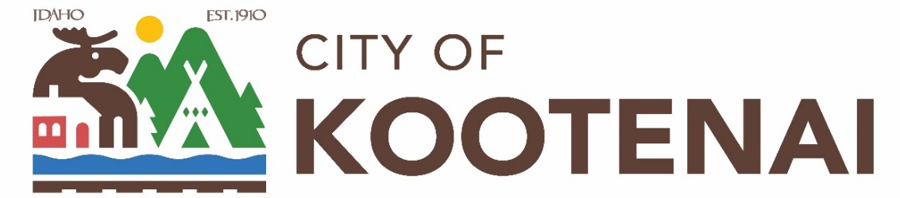

BUDGET WORKSHOP

Kootenai City Hall
204 Spokane, Kootenai, Idaho

Tuesday, June 16, 2026
6:00 P.M.

PUBLIC IS WELCOME TO ATTEND PHYSICALLY – CAPACITY LIMIT – 15
TELECONFRENCE/VIDEO IS AVALIABLE
USING THE FOLLOWING INFORMATION:

Meeting URL: https://gomeet.com/pcsysqycea
Optional Dial-In Number: 571-748-4021
PIN: 1514180#
Quick dial (mobile): 571-748-4021, 1514180#

WORKSHOP MEETING

AGENDA ITEMS:

- Budget Workshop – 1st Review and consideration for FY 2027 City Budget

No action will be taken, or decisions made during this workshop.

