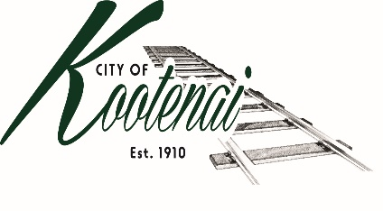
CITY OF KOOTENAI

COUNCIL MEETING

AGENDA

KOOTENAI CITY HALL

204 SPOKANE STREET

Tuesday, December 5, 2023

TIME: 6:30 P.M.

PUBLIC IS WELCOME TO ATTEND PHYSICALLY – CAPACITY LIMIT – 15

TELECONFRENCE/VIDEO IS AVALIABLE

USING THE FOLLOWING INFORMATION:
Meeting URL: https://gomeet.com
Optional Dial-In Number: 571-748-4021
PIN: 1514180#

Pledge of Allegiance/Roll Call:

Amendments to the Agenda/ Announcements

General Public Comment: Each speaker will be allowed a maximum of 3 minutes to speak on subjects outside of the agenda items unless additional information is requested by Mayor/Council. Written comments must be submitted at least 1 business day before the meeting date.

Agenda Public Comment: Public may speak on the following agenda items. A signup sheet will be provided.

Public Hearing Public Comment: A sign in sheet will be provided to request public hearing comments.

1. Consent Agenda: ACTION

Notice to the Public: All matters listed within the Consent Agenda have been distributed to each council member for review, are considered to be routine, and will be enacted on by one motion of the Council with no separate discussion. If separate discussion is desired, that item may be removed from the Consent Agenda and placed on the Regular Agenda by request.
  - Approval of minutes for the November 7, 2023, Council Meeting and November 28, 2023 workshop.
  - Approval of Bills and Payroll – November 2023

2. Reports:

2.A Mayor:

2.B City Engineer: Written Report Summary

2.B1 Idaho Strategic Initiatives Grant Program – Update

2.B2 General Street Maintenance – Update

2.B3 Second Avenue Widening Project - Update

2.C City Planner: Written Report Summary

2.C1 Building Permit and Land Use Activity – Update

2.C2 Land Use Application Activity – PLA02-22, Adams Parcel Line Adjustment – ACTION

2.C3 BC File MLD0046-23, Rains Minor Land Division Request (Up the Road Ranch) – ACTION

2.C4 BC File S0002-23, Providence Subdivision Reconsideration Hearing – Update

2.C5 City of Sandpoint Comprehensive Plan Public Comment - ACTION

2.D Selkirks-Pend Oreille Transit (SPOT):

2.E Clerk: Written Report: Written Report Summary

2.F Park Committee – Update

3. Executive Session - Motion to move Council, Pursuant to Idaho Code 74-206(a), Convene into Executive Session to consider hiring a public officer, employee, staff member or individual agent, wherein the respective qualities of individuals are to be evaluated in order to fill a particular vacancy or need.

4. Discussion/Action Items:

3.1 State/Local Agreement for SH 200 to Railroad Avenue Project – Authorization to sign and pay-ACTION

3.2 SH 200 to Railroad Ave Project – Resolution - ACTION

3.2 BookMobile – City Hall Parking Lot - ACTION

3.3 New City Clerk - Consideration for appointment – ACTION

5. Adjournment

