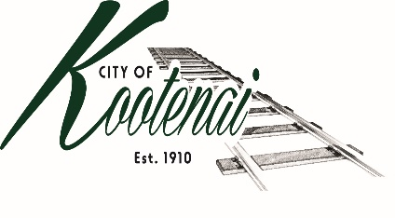
CITY OF KOOTENAI

COUNCIL MEETING AND PUBLIC HEARING

AGENDA

KOOTENAI CITY HALL

204 SPOKANE STREET

Tuesday, November 7, 2023

TIME: 6:30 P.M.

PUBLIC IS WELCOME TO ATTEND PHYSICALLY – CAPACITY LIMIT – 15

TELECONFRENCE/VIDEO IS AVALIABLE

USING THE FOLLOWING INFORMATION:
Meeting URL: https://gomeet.com
Optional Dial-In Number: 571-748-4021
PIN: 1514180#

Pledge of Allegiance/Roll Call:

Amendments to the Agenda/ Announcements

General Public Comment: Each speaker will be allowed a maximum of 3 minutes to speak on subjects outside of the agenda items unless additional information is requested by Mayor/Council. Written comments must be submitted at least 1 business day before the meeting date.

Agenda Public Comment: Public may speak on the following agenda items. A signup sheet will be provided.

Public Hearing Public Comment: A sign in sheet will be provided to request public hearing comments.

PUBLIC HEARING – FILE #SUP001-23 DRESSEL SPECIAL USE PERMIT AT 311 W SECOND AVE

1. Consent Agenda: ACTION

Notice to the Public: All matters listed within the Consent Agenda have been distributed to each council member for review, are considered to be routine, and will be enacted on by one motion of the Council with no separate discussion. If separate discussion is desired, that item may be removed from the Consent Agenda and placed on the Regular Agenda by request.
  - Approval of minutes for the October 3, 2023, Council Meeting and October 19, 2023 workshop.
  - Approval of Bills and Payroll – October 2023

2. Reports:

2.A Mayor:

2.B City Engineer: Written Report Summary

2.B1 Idaho Strategic Initiatives Grant Program – Update

2.B2 Street Maintenance – Update

2.B3 Second Avenue Widening Project – Update

2.B4 Stormwater and Encroachment - Update

2.C City Planner: Written Report Summary

2.C1 Building Permit and Land Use Activity – Update

2.C2 PLA02-22 – Parcel Line Adjustment – Adams – ACTION

2.C3 BC File ZC0006-23 – Zone Change Request – Rains - ACTION

2.C4 BC File SS0003-21 – Whiskey Jack – Phase 1 – ACTION

2.C5 BC File SS0002-23 – Providence Subdivision – ACTION

2.C6 BC File VA0020-2 – Administrative Variance Request – ACTION

2.D Selkirks-Pend Oreille Transit (SPOT):

2.E Clerk: Written Report: Written Report Summary

2.F Park Committee – Update

3. Discussion/Action Items:

3.1 Authorization for additional architectural services from Architecture 311.5 – ACTION

3.2 4th Quarter Financial Report – Approval and Authorization to publish.

4. Adjournment

