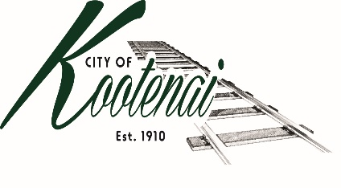
CITY OF KOOTENAI

COUNCIL MEETING

AGENDA

KOOTENAI CITY HALL

204 SPOKANE STREET

Tuesday, August 1, 2023

TIME: 6:30 P.M.

PUBLIC IS WELCOME TO ATTEND PHYSICALLY – CAPACITY LIMIT – 15

TELECONFRENCE/VIDEO IS AVALIABLE

USING THE FOLLOWING INFORMATION:
Meeting URL: https://gomeet.com/pcsysqycea
Optional Dial-In Number: 571-748-4021
PIN: 1514180#

Pledge of Allegiance/Roll Call:

Amendments to the Agenda/ Announcements

General Public Comment: Each speaker will be allowed a maximum of 3 minutes to speak on subjects outside of the agenda items unless additional information is requested by Mayor/Council. Written comments must be submitted at least 1 business day before the meeting date.

Public Hearing Public Comment: Comments on matters set for future public hearing(s) is not permitted.

Agenda Public Comment: Public may speak on the following agenda items. A signup sheet will be provided.

1. Consent Agenda: ACTION

Notice to the Public: All matters listed within the Consent Agenda have been distributed to each council member for review, are considered to be routine, and will be enacted on by one motion of the Council with no separate discussion. If separate discussion is desired, that item may be removed from the Consent Agenda and placed on the Regular Agenda by request.
  - Approval of minutes for the July 11, 2023, July 18, 2023 Budget Workshop

1.2 Approval of Bills and Payroll – July 2023

2. Reports:

2.A Mayor:

2.B City Engineer: Written Report Summary

2.B1 Idaho Strategic Initiatives Grant Program - ACTION

2.B2 City Parking Lot – Update

2.B3 Helena Street Paving – Update

2.B4 Planning Support/Stormwater Review - Update

2.B5 Encroachment Permits – Update

2.C City Planner: Written Report Summary

2.C1 Building permit activity – Advisory

2.C2 Land Use Application Activity – Advisory

2.C3 Area of City Impact, Providence Subdivision - Advisory

2.D City of Sandpoint Law Enforcement – Written Report Summary

2.D1 Calls for Service – update

2.E Selkirks-Pend Oreille Transit (SPOT):

2.F Clerk: Written Report: Written Report Summary

3.F1 Administrative – update

2.G Park Committee - Update

3. Discussion/Action Items:

3.1 3rd Quarter Financial Report – Approval and Authorization to Publish - ACTION

3.2 Temporary Certificate of Occupancy for 223 Brittany Loop - ACTION

4. Adjournment

