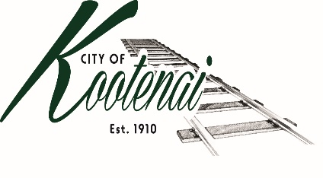
CITY OF KOOTENAI

COUNCIL MEETING

AGENDA

KOOTENAI CITY HALL

204 SPOKANE STREET

Tuesday, April 4, 2023

TIME: 6:30 P.M.

PUBLIC IS WELCOME TO ATTEND PHYSICALLY – CAPACITY LIMIT – 15

TELECONFRENCE/VIDEO IS AVALIABLE

USING THE FOLLOWING INFORMATION:
Meeting URL: https://gomeet.com/pcsysqycea
Optional Dial-In Number: 571-748-4021
PIN: 1514180#

Pledge of Allegiance/Roll Call:

Amendments to the Agenda/ Announcements

Public Comment: Each speaker will be allowed a maximum of 3 minutes unless additional information is requested by Mayor/Council. Written comments must be submitted at least 1 business day before the meeting date. Comments on matters set for future public hearing(s) is not permitted.

1. Consent Agenda: ACTION

Notice to the Public: All matters listed within the Consent Agenda have been distributed to each council member for review, are considered to be routine, and will be enacted on by one motion of the Council with no separate discussion. If separate discussion is desired, that item may be removed from the Consent Agenda and placed on the Regular Agenda by request.
  - Approval of minutes for the Council Meeting of March 7, 2023, and Code Enforcement Workshop of March 13, 2023
  - Approval of Bills and Payroll – March 2023

2. Reports:

2.A Mayor:

2.B City Engineer: Written Report Summary

2.B1 Children Pedestrian Safety Grant - Update

2.B2 SH-200 Safety Improvements and TAP Grant - Update

2.B3 City Parking Lot

2.B4 Weight Limits Update

2.B5 Amendment #6 and Authorization for Engineering Consulting Services for an update of the Pavement Management Plan - ACTION

2.C City Planner: Written Report Summary

2.C1 Building Permit Activity – Advisory

2.C2 Land use Application Activity – Advisory

2.C3 Violations - Advisory

2.C4 Land use Files – Adams Family Subdivision Continued– ACTION

2.C5 Planning Projects – Next Code Update Workshop – April 17th at 6 p.m.

2.D City of Sandpoint Law Enforcement – Written Report Summary

2.D1 Calls for Service – update

2.E Selkirks-Pend Oreille Transit (SPOT):

2.F Clerk: Written Report: Written Report Summary

3.F1 Administrative – update

2.G Park Committee:

3. Discussion/Action Items:

3.1 Final FY 2022 Audit – ACTION

3.2 Resolution #95 Records Retention - ACTION

3.3 Set Date for Budget Hearing – ACTION

3.4 Surplus Security Equipment – ACTION

3.5 City Park Use: Policy and Fee Schedule - ACTION

4. Adjournment

