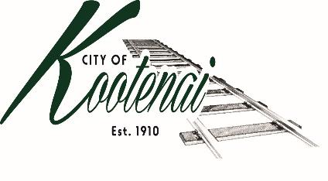
CITY OF KOOTENAI

COUNCIL MEETING

AGENDA

KOOTENAI CITY HALL
204 SPOKANE STREET
Tuesday, December 6, 2022
TIME: 6:30 P.M.
PUBLIC IS WELCOME TO ATTEND PHYSICALLY – CAPACITY LIMIT – 15
TELECONFRENCE/VIDEO IS AVALIABLE
USING THE FOLLOWING INFORMATION:
Meeting URL: https://gomeet.com/pcsysqycea
Optional Dial-In Number: 571-748-4021
PIN: 1514180#
Quick dial (mobile): 571-748-4021, 1514180#
Pledge of Allegiance/Roll Call:

Amendments to the Agenda/ Announcements

Public Comment: Each speaker will be allowed a maximum of 3 minutes unless additional information is requested by Mayor/Council. Written comments must be submitted at least 1 business day before the meeting date. Comments on matters set for future public hearing(s) is not permitted.
1. Consent Agenda: ACTION
Notice to the Public: All matters listed within the Consent Agenda have been distributed to each council member for review, are considered to be routine, and will be enacted on by one motion of the Council with no separate discussion. If separate discussion is desired, that item may be removed from the Consent Agenda and placed on the Regular Agenda by request.
  - Approval of minutes for the Council Meeting of November 1, 2022.
  - Approval of Bills and Payroll

2. Reports:
2.A Mayor:

2.B City Engineer: Written Report Summary
2.B1 Children Pedestrian Safety Grant -Update

2.C City Planner: Written Report Summary
2.C1 Building Permit Activity – Advisory
2.C2 Land Use Application Activity – Advisory
2.C3 File CUP0016-22, Conditional Use Permit- ADVISORY/ACTION
2.C4 Bonner County – AM0012- ADVISORY/ACTION
2.C5 Bonner County – AM0015- ADVISORY/ACTION
2.C6 Bonner County - AM0017-ADVISORY
2.C3 Bonner County-AM0018- ADVISORY/ACTION

2.D City of Sandpoint Law Enforcement – Written Report Summary
4.D1 Calls for Service – update

2.E Selkirks-Pend Oreille Transit (SPOT):

2.F Clerk: Written Report: Written Report Summary
2.F1 Administrative – update

2.G Park Committee: Grant Opportunities

2.H Vegetation Management
2.H1 Priority Tree Health Removal within City rights-of-ways - Update

3. Discussion/Action Items:
3.1 City Personnel Policy – ACTION
3.2 Additional parking for staff – Update

4. Adjournment

