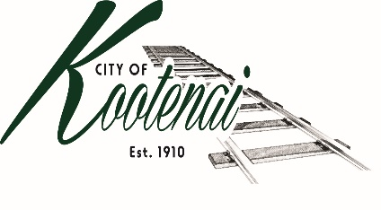
CITY OF KOOTENAI

COUNCIL MEETING

AGENDA

KOOTENAI CITY HALL

204 SPOKANE STREET

Tuesday, August 2, 2022

TIME: 6:30 P.M.

PUBLIC IS WELCOME TO ATTEND PHYSICALLY – CAPACITY LIMIT – 15

TELECONFRENCE/VIDEO IS AVALIABLE

USING THE FOLLOWING INFORMATION:
Meeting URL: https://gomeet.com/pcsysqycea
Optional Dial-In Number: 571-748-4021
PIN: 1514180#
Quick dial (mobile): 571-748-4021, 1514180#

Pledge of Allegiance/Roll Call:

Amendments to the Agenda/ Announcements

Public Comment: Each speaker will be allowed a maximum of 3 minutes unless additional information is requested by Mayor/Council. Written comments must be submitted at least 1 business day before the meeting date. Comments on matters set for future public hearing(s) is not permitted.
1. Consent Agenda: ACTION

Notice to the Public: All matters listed within the Consent Agenda have been distributed to each council member for review, are considered to be routine, and will be enacted on by one motion of the Council with no separate discussion. If separate discussion is desired, that item may be removed from the Consent Agenda and placed on the Regular Agenda by request.
  - Approval of minutes for the Council Meeting of July 5, 2022 and Special Meeting and Budget Workshop of July 20, 2022.

1.2 Approval of Bills and Payroll

2. Reports:

2.A Mayor:

2.B City Engineer: Written Report Summary

2.B1 TAP Grant Pathway – ACTION

2.B2 Children Pedestrian Safety Program Grant - ACTION

2.B3 Utility Permits – Update

2.B4 Ditch Maintenance - Update

2.C City Planner: Written Report Summary

2.C1 Building Permit Activity – Advisory

2.C2 Land Use Application Activity – Advisory

2.D City of Sandpoint Law Enforcement – Written Report Summary

2.D1 Calls for Service – update

2.E Selkirks-Pend Oreille Transit (SPOT):

2.F Clerk: Written Report: Written Report Summary

2.F1 Administrative – update

2.G Park Committee:

3. Executive Session –In accordance with Idaho Code §74-206(f) to communicate with legal counsel for the public agency to discuss the legal ramifications of and legal options for pending litigation, or controversies not yet being litigated by imminently likely to be litigated.

4. Discussion/Action Items:

4.1 Lignetics – update

4.2 Bonner County Historical Society – Free Title – ACTION

4.3 Code Enforcement – Title 4 and Title 8 Enforcement – ACTION

4.4 Surplus Inventory – ACTION

4.5 3rd Quarter Financial Report – Approval and authorization to publish - ACTION

5. Adjournment

