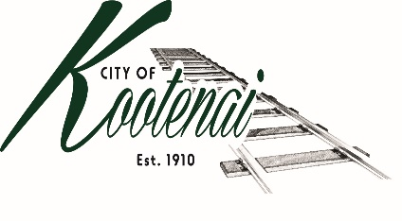
CITY OF KOOTENAI

COUNCIL MEETING

AGENDA

KOOTENAI CITY HALL

204 SPOKANE STREET

Tuesday, April 5, 2022

TIME: 6:30 P.M.

PUBLIC IS WELCOME TO ATTEND PHYSICALLY – CAPACITY LIMIT – 15

TELECONFRENCE/VIDEO IS AVALIABLE

USING THE FOLLOWING INFORMATION:
Meeting URL: https://gomeet.com/pcsysqycea
Optional Dial-In Number: 571-748-4021
PIN: 1514180#
Quick dial (mobile): 571-748-4021, 1514180#

Pledge of Allegiance/Roll Call:

Amendments to the Agenda/ Announcements

Public Comment: Each speaker will be allowed a maximum of 3 minutes unless additional information is requested by Mayor/Council. Written comments must be submitted at least 1 business day before the meeting date. Comments on matters set for future public hearing(s) is not permitted.

1. Consent Agenda: ACTION

Notice to the Public: All matters listed within the Consent Agenda have been distributed to each council member for review, are considered to be routine, and will be enacted on by one motion of the Council with no separate discussion. If separate discussion is desired, that item may be removed from the Consent Agenda and placed on the Regular Agenda by request.
  - Approval of minutes for the Public Hearing and Council Meeting of March 1, 2022

1.2 Approval of Bills and Payroll

2. Reports:

2.A Mayor:

2.B City Engineer: Written Report Summary

2.B1 Urban Area Transportation Plan – Update

2.B2 Weight Limits – Advisory

2.B3 Helena Right-of-Way - Advisory

2.C City Planner: Written Report Summary

2.C1 Building Permit Activity - Update

2.C2 Land Use Applications – Advisory

2.C3 Bonner County All-Hazards Plan Letter of Intent – ACTION

2.C4 Bonner County Requests to Comment – ACTION/ADVISORY

2.C5 Area of City Impact follow up - ADVISORY

2.D City of Sandpoint Law Enforcement – Written Report Summary

2.D1 Calls for Service – update

2.E Selkirks-Pend Oreille Transit (SPOT):

2.F Clerk: Written Report: Written Report Summary

2.F1 Administrative – update

3. Discussion/Action Items:

3.1 Independent Highway District Memorandum of Understanding – ACTION

3.2 Memorandum of Agreement – Spokane Conservation District – ACTION

3.3 Lignetics - update

3.4 Budget Workshops and Public Hearing Date – Discussion

3.5 Tree Maintenance Letter - Discussion

4. Executive Session – Convene in Executive Session to in accordance with Idaho Code §74-206(a) to consider hiring a public officer, employee, staff member or individual agent, wherein the respective qualities of individuals are to be evaluated in order to fill a particular vacancy or need. This paragraph does not apply to filling a vacancy in an elective office or deliberations about staffing needs in general.

5. Adjournment

