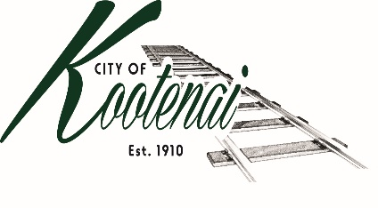
CITY OF KOOTENAI

COUNCIL MEETING

AND

COMPREHENSIVE PLAN REVIEW WORKSHOP

AGENDA

KOOTENAI CITY HALL

204 SPOKANE STREET

Tuesday, February 1, 2022

TIME: 6:30 P.M.

PUBLIC IS WELCOME TO ATTEND PHYSICALLY – CAPACITY LIMIT – 15

TELECONFRENCE/VIDEO IS AVALIABLE

USING THE FOLLOWING INFORMATION:
Meeting URL: https://gomeet.com/pcsysqycea
Optional Dial-In Number: 571-748-4021
PIN: 1514180#
Quick dial (mobile): 571-748-4021, 1514180#

Pledge of Allegiance/Roll Call:

Amendments to the Agenda/ Announcements
Public Comment: Each speaker will be allowed a maximum of 3 minutes unless additional information is requested by Mayor/Council. Written comments must be submitted at least 1 business day before the meeting date. Comments on matters set for future public hearing(s) is not permitted.
1. Consent Agenda: ACTION

Notice to the Public: All matters listed within the Consent Agenda have been distributed to each council member for review, are considered to be routine, and will be enacted on by one motion of the Council with no separate discussion. If separate discussion is desired, that item may be removed from the Consent Agenda and placed on the Regular Agenda by request.

1.1 Approval of the minutes of Council Meeting January 4, 2022.

1.2 Approval of Bills and Payroll

2. Reports:

2.A Mayor:

2.B City Engineer: Written Report Summary

2.B1 Children Pedestrian Safety Grant Application - Update

2.B2 Urban Area Transportation Plan – Update

2.B3 Permit Activities - Update

2.C City Planner: Written Report Summary

2.C1 Building Permit Activity - Update

2.C2 Comprehensive Final Draft - Update

2.C3 All Seasons Notice of Extension - Update

2.D City of Sandpoint Law Enforcement – Written Report Summary

2.D1 Calls for Service – update

2.E Selkirks-Pend Oreille Transit (SPOT):

2.F Clerk: Written Report: Written Report Summary

2.F1 Administrative – update

3. Discussion/Action Items:

3.1 1st Quarter Financial Report – Approval and Authorization to Publish- ACTION

3.2 Sandpoint Law Enforcement Second Amendment to Joint Powers Agreement – ACTION

3.3 Lignetics Debris - Discussion

4. Adjournment

Comprehensive Plan Review Workshop – Final Review of the City’s Amended Comprehensive Plan

