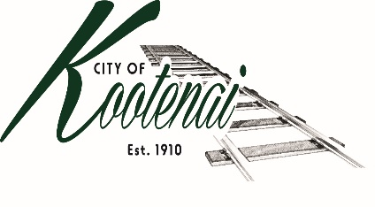
CITY OF KOOTENAI

COUNCIL MEETING

AGENDA

KOOTENAI CITY HALL

204 SPOKANE STREET

Tuesday, November 2, 2021

TIME: 6:30 P.M.

PUBLIC IS WELCOME TO ATTEND PHYSICALLY – CAPACITY LIMIT – 15

TELECONFRENCE/VIDEO IS AVALIABLE

USING THE FOLLOWING INFORMATION:
Meeting URL: https://gomeet.com/pcsysqycea
Optional Dial-In Number: 571-748-4021
PIN: 1514180#
Quick dial (mobile): 571-748-4021, 1514180#

Pledge of Allegiance/Roll Call:

Amendments to the Agenda/ Announcements
Public Comment: Each speaker will be allowed a maximum of 3 minutes unless additional information is requested by Mayor/Council. Written comments must be submitted at least 1 business day before the meeting date. Comments on matters set for future public hearing(s) is not permitted
1. Consent Agenda: ACTION

Notice to the Public: All matters listed within the Consent Agenda have been distributed to each council member for review, are considered to be routine, and will be enacted on by one motion of the Council with no separate discussion. If separate discussion is desired, that item may be removed from the Consent Agenda and placed on the Regular Agenda by request.

1.1 Approval of the minutes of Council Meeting October 5, 2021, and Comprehensive Plan Workshop October 20, 2021.

1.2 Approval of Bills and Payroll

2. Reports:

2.A Mayor:

2.B City Engineer: Written Report Summary

2.B1 Hwy 200 Improvements/TAP Grant – Update

2.B2 ARPA Fund Project – Update

2.B3 ADA Swing – Update

2.B4 Permit - Update

2.C City Planner: Written Report Summary

2.C1 Building permit activity – update

2.C2 Comprehensive Plan - update

2.D City of Sandpoint Law Enforcement – Written Report Summary

2.D1 Calls for Service – update

2.E Selkirks-Pend Oreille Transit (SPOT):

2.F Clerk: Written Report: Written Report Summary

2.F1 Administrative – update

3. Discussion/Action Items:

3.1 4th Quarter Financial Report – Authorization to Publish - ACTION

3.2 Tree Inventory Advisory Letter – ACTION

3.3 Use of City Rights-of-Ways Advisement Letter – ACTION

4. Executive Session - Executive Session - Convene in Executive Session to in accordance with Idaho Code §74-206(f) to communicate with legal counsel for the public agency to discuss the legal ramifications of and legal options for pending litigation, or controversies not yet being litigated by imminently likely to be litigated.

5. Adjournment

