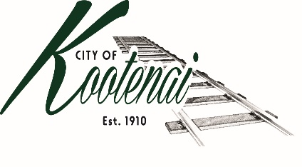
CITY OF KOOTENAI

COUNCIL MEETING

AGENDA

KOOTENAI CITY HALL

204 SPOKANE STREET

Tuesday, August 3, 2021

TIME: 6:30 P.M.

PUBLIC IS WELCOME TO ATTEND PHYSICALLY – CAPACITY LIMIT – 15

TELECONFRENCE/VIDEO IS AVALIABLE

USING THE FOLLOWING INFORMATION:
Meeting URL: https://gomeet.com/pcsysqycea
Optional Dial-In Number: 571-748-4021
PIN: 1514180#
Quick dial (mobile): 571-748-4021, 1514180#

Pledge of Allegiance/Roll Call:

Amendments to the Agenda/ Announcements
Public Comment: Each speaker will be allowed a maximum of 3 minutes unless additional information is requested by Mayor/Council. Written comments must be submitted at least 1 business day before the meeting date. Comments on matters set for future public hearing(s) is not permitted
Mike Hammack – Proposed development within the City’s Area of City Impact – Information only
1. Consent Agenda: ACTION

Notice to the Public: All matters listed within the Consent Agenda have been distributed to each council member for review, are considered to be routine, and will be enacted on by one motion of the Council with no separate discussion. If separate discussion is desired, that item may be removed from the Consent Agenda and placed on the Regular Agenda by request.

1.1 Approval of the minutes of Council Meeting July 6, 2021, and July 21, 2021 Special Meeting and Budget Workshop.

1.2 Approval of Bills and Payroll

2. Reports:

2.A Mayor: Report: Addressing Memorandum of Understanding with Bonner County - update

2.B City Engineer: Written Report Summary

2.B1 Second Ave Project Update – Update

2.B2 Main Street Chip Seal - Update

2.B3 Permit Activities – Update

2.B4 American Rescue Plan Act (ARPA) - Discussion

2.C City Planner: Written Report Summary

2.C1 Building Activity – Update

2.C2 Comprehensive Plan - Update

2.D City of Sandpoint Law Enforcement – Written Report Summary

2.D1 Calls for Service – update

2.E Selkirks-Pend Oreille Transit (SPOT):

2.F Clerk: Written Report: Written Report Summary

2.F1 Administrative – update

3. Discussion/Action Items:

3.1 Ting – Waiver of Public Works License Request - ACTION

3.2 Bid for City Hall Roofing Project – ACTION

3.3 Bonner County Addressing Memorandum of Understanding (MOU) – ACTION

3.4 Alternate Code Administrator – Contract and Scope of Work and appointment - ACTION

4. Adjournment

