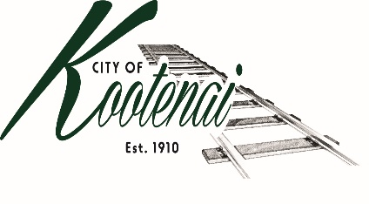
CITY OF KOOTENAI

COUNCIL MEETING

AGENDA

KOOTENAI CITY HALL

204 SPOKANE STREET

Tuesday, July 6, 2021

TIME: 6:30 P.M.

PUBLIC IS WELCOME TO ATTEND PHYSICALLY – CAPACITY LIMIT – 15

TELECONFRENCE/VIDEO IS AVALIABLE

USING THE FOLLOWING INFORMATION:
Meeting URL: https://gomeet.com/pcsysqycea
Optional Dial-In Number: 571-748-4021
PIN: 1514180#
Quick dial (mobile): 571-748-4021, 1514180#

Pledge of Allegiance/Roll Call:

Amendments to the Agenda

Public Comment: Each speaker will be allowed a maximum of 3 minutes unless additional information is requested by Mayor/Council. Written comments must be submitted at least 1 business day before the meeting date. Comments on matters set for future public hearing(s) is not permitted

Announcements:

1. Consent Agenda: ACTION

Notice to the Public: All matters listed within the Consent Agenda have been distributed to each council member for review, are considered to be routine, and will be enacted on by one motion of the Council with no separate discussion. If separate discussion is desired, that item may be removed from the Consent Agenda and placed on the Regular Agenda by request.

1.1 Approval of the minutes of Council Meeting June 1, 2021, and Budget Workshop June 16, 2021

1.2 Approval of Bills and Payroll

2. Reports:

2.A Mayor: Report: Addressing Memorandum of Understanding with Bonner County - update

2.B City Engineer: Written Report Summary

2.B1 Bid Paving for Second Ave – ACTION

2.B2 Fiber Optic Infrastructure - Update

2.B3 Permit Activities – Update

2.B4 N. Main Street Chip Seal – ACTION

2.C City Planner: Written Report Summary

2.C1 Building Activity – Update

2.C2 Wahlin Property Line Adjustment – File PLA01-21 - ACTION

2.D City of Sandpoint Law Enforcement – Written Report Summary

2.D1 Calls for Service – update

2.E Selkirks-Pend Oreille Transit (SPOT):

2.F Clerk: Written Report: Written Report Summary

2.F1 Administrative – update

3. Discussion/Action Items:

3.1 Bid from FM Roofing – ACTION

3.2 3rh Qtr Financial Report - ACTION

3.2 Northside Fire Impact Fee Process – update

3.3 Wahlin Temporary Certificate of Occupancy – ACTION

3.4 Whitney Moreno – Cottonwood at the corner of Kootenai Meadow and Kegan Court

3.5 Avista Franchise - update

3.6 Unpermitted Culvert/Driveway in Seven Sisters Subdivision – ACTION

4. Executive Session – Executive Session - Convene in Executive Session to in accordance with Idaho Code §74-206(f) to communicate with legal counsel for the public agency to discuss the legal ramifications of and legal options for pending litigation, or controversies not yet being litigated by imminently likely to be litigated.

5. Adjournment

