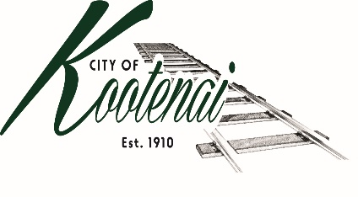
CITY OF KOOTENAI

COUNCIL MEETING

AGENDA

KOOTENAI CITY HALL

204 SPOKANE STREET

Tuesday, June 1, 2021

TIME: 6:30 P.M.

PUBLIC IS WELCOME TO ATTEND PHYSICALLY – CAPACITY LIMIT – 15

TELECONFRENCE/VIDEO IS AVALIABLE

USING THE FOLLOWING INFORMATION:
Meeting URL: https://gomeet.com/pcsysqycea
Optional Dial-In Number: 571-748-4021
PIN: 1514180#
Quick dial (mobile): 571-748-4021, 1514180#

Pledge of Allegiance/Roll Call:

Amendments to the Agenda

Public Comment: Each speaker will be allowed a maximum of 3 minutes unless additional information is requested by Mayor/Council. Written comments must be submitted at least 1 business day before the meeting date. Comments on matters set for future public hearing(s) is not permitted

Announcements:

1. Consent Agenda: ACTION

Notice to the Public: All matters listed within the Consent Agenda have been distributed to each council member for review, are considered to be routine, and will be enacted on by one motion of the Council with no separate discussion. If separate discussion is desired, that item may be removed from the Consent Agenda and placed on the Regular Agenda by request.

1.1 Approval of the minutes of Public Hearing and Regular Council Meeting May 4, 2021

1.2 Approval of Bills and Payroll

2. Reports:

2.A Mayor: Report:

2.B City Engineer: Written Report Summary

2.B1 Hwy 200 Improvements – Update

2.B2 2nd Ave Extension – Update

2.B3 Permit Activities - Update

2.C City Planner: Written Report Summary

2.C1 Contract Land Use Planner Rate Increase - ACTION

2.C2 Planning Activity - Update

2.C3 Building Activity – Update

2.C4 Bonner County – AM0004-21

2.C5 Bonner County – SS0001-21

2.C6 Wahlin Property Line Adjustment – File PLA01-21 - ACTION

2.D City of Sandpoint Law Enforcement – Written Report Summary

2.D1 Calls for Service – update

2.E Selkirks-Pend Oreille Transit (SPOT):

2.F Clerk: Written Report: Written Report Summary

2.F1 Administrative – update

3. Discussion/Action Items:

Bonner County Addressing MOU – ACTION

City of Ponderay – AM21-022 - ACTION

District Fire Department Impact Fees – Discussion

Sub-Pump Drainage re-route – ACTION

Tree Inventory - Discussion

4. Executive Session – Executive Session - Convene in Executive Session to in accordance with Idaho Code §74-206(f) to communicate with legal counsel for the public agency to discuss the legal ramifications of and legal options for pending litigation, or controversies not yet being litigated by imminently likely to be litigated.

5. Adjournment:

