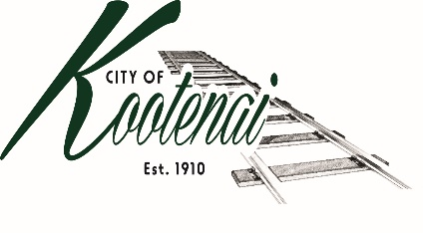
CITY OF KOOTENAI

COUNCIL MEETING

AGENDA AND PUBLIC HEARING

KOOTENAI CITY HALL

204 SPOKANE STREET

Tuesday, May 4, 2021

PUBLIC IS WELCOME TO ATTEND PHYSICALLY – CAPACITY LIMIT – 15.

TELECONFRENCE/VIDEO IS AVALIABLE

USING THE FOLLOWING INFORMATION:
Meeting URL: https://gomeet.com/pcsysqycea
Optional Dial-In Number: 571-748-4021
PIN: 1514180#
Quick dial (mobile): 571-748-4021, 1514180#

Pledge of Allegiance/Roll Call:

PUBLIC HEARING – Council to consider adopting a franchise agreement with FatBeam - ACTION

Amendments to the Agenda

Public Comment: Each speaker will be allowed a maximum of 3 minutes unless additional information is requested by Mayor/Council. Written comments must be submitted at least 1 business day before the meeting date. Comments on matters set for future public hearing(s) is not permitted

Announcements:

Presentation – Northside Fire Department – Vern Roof - Impact Fees

1. Consent Agenda: ACTION

Notice to the Public: All matters listed within the Consent Agenda have been distributed to each council member for review, are considered to be routine, and will be enacted on by one motion of the Council with no separate discussion. If separate discussion is desired, that item may be removed from the Consent Agenda and placed on the Regular Agenda by request.

1.1 Approval of the minutes of April 6, 2021 Regular Council Meeting.

1.2 Approval of Bills and Payroll

2. Reports:

2.A Mayor: Report:

2.B City Engineer:

2.B1 Weight Limits – update

2.B2 Urban Area Transportation Plan – update

2.B3 Highway 200 Improvements - update

2.C City Planner: Written Report Summary

2.C1 Building Permit and Land Use Activity – update

2.C2 Census data and Comp Plan – update

2.C3 ACI – Bonner County AM008-21 - ACTION

2.D City of Sandpoint Law Enforcement – Written Report Summary

2.D1 Calls for Service – update

2.E Selkirks-Pend Oreille Transit (SPOT):

2.F Clerk: Written Report: Written Report Summary

2.F1 Administrative – update

3. Discussion/Action Items:

3.1 Draft Addressing Memorandum of Understanding with Bonner County – ACTION

3.2 City’s 2nd Quarter Financial Report - ACTION

4. Adjournment:

